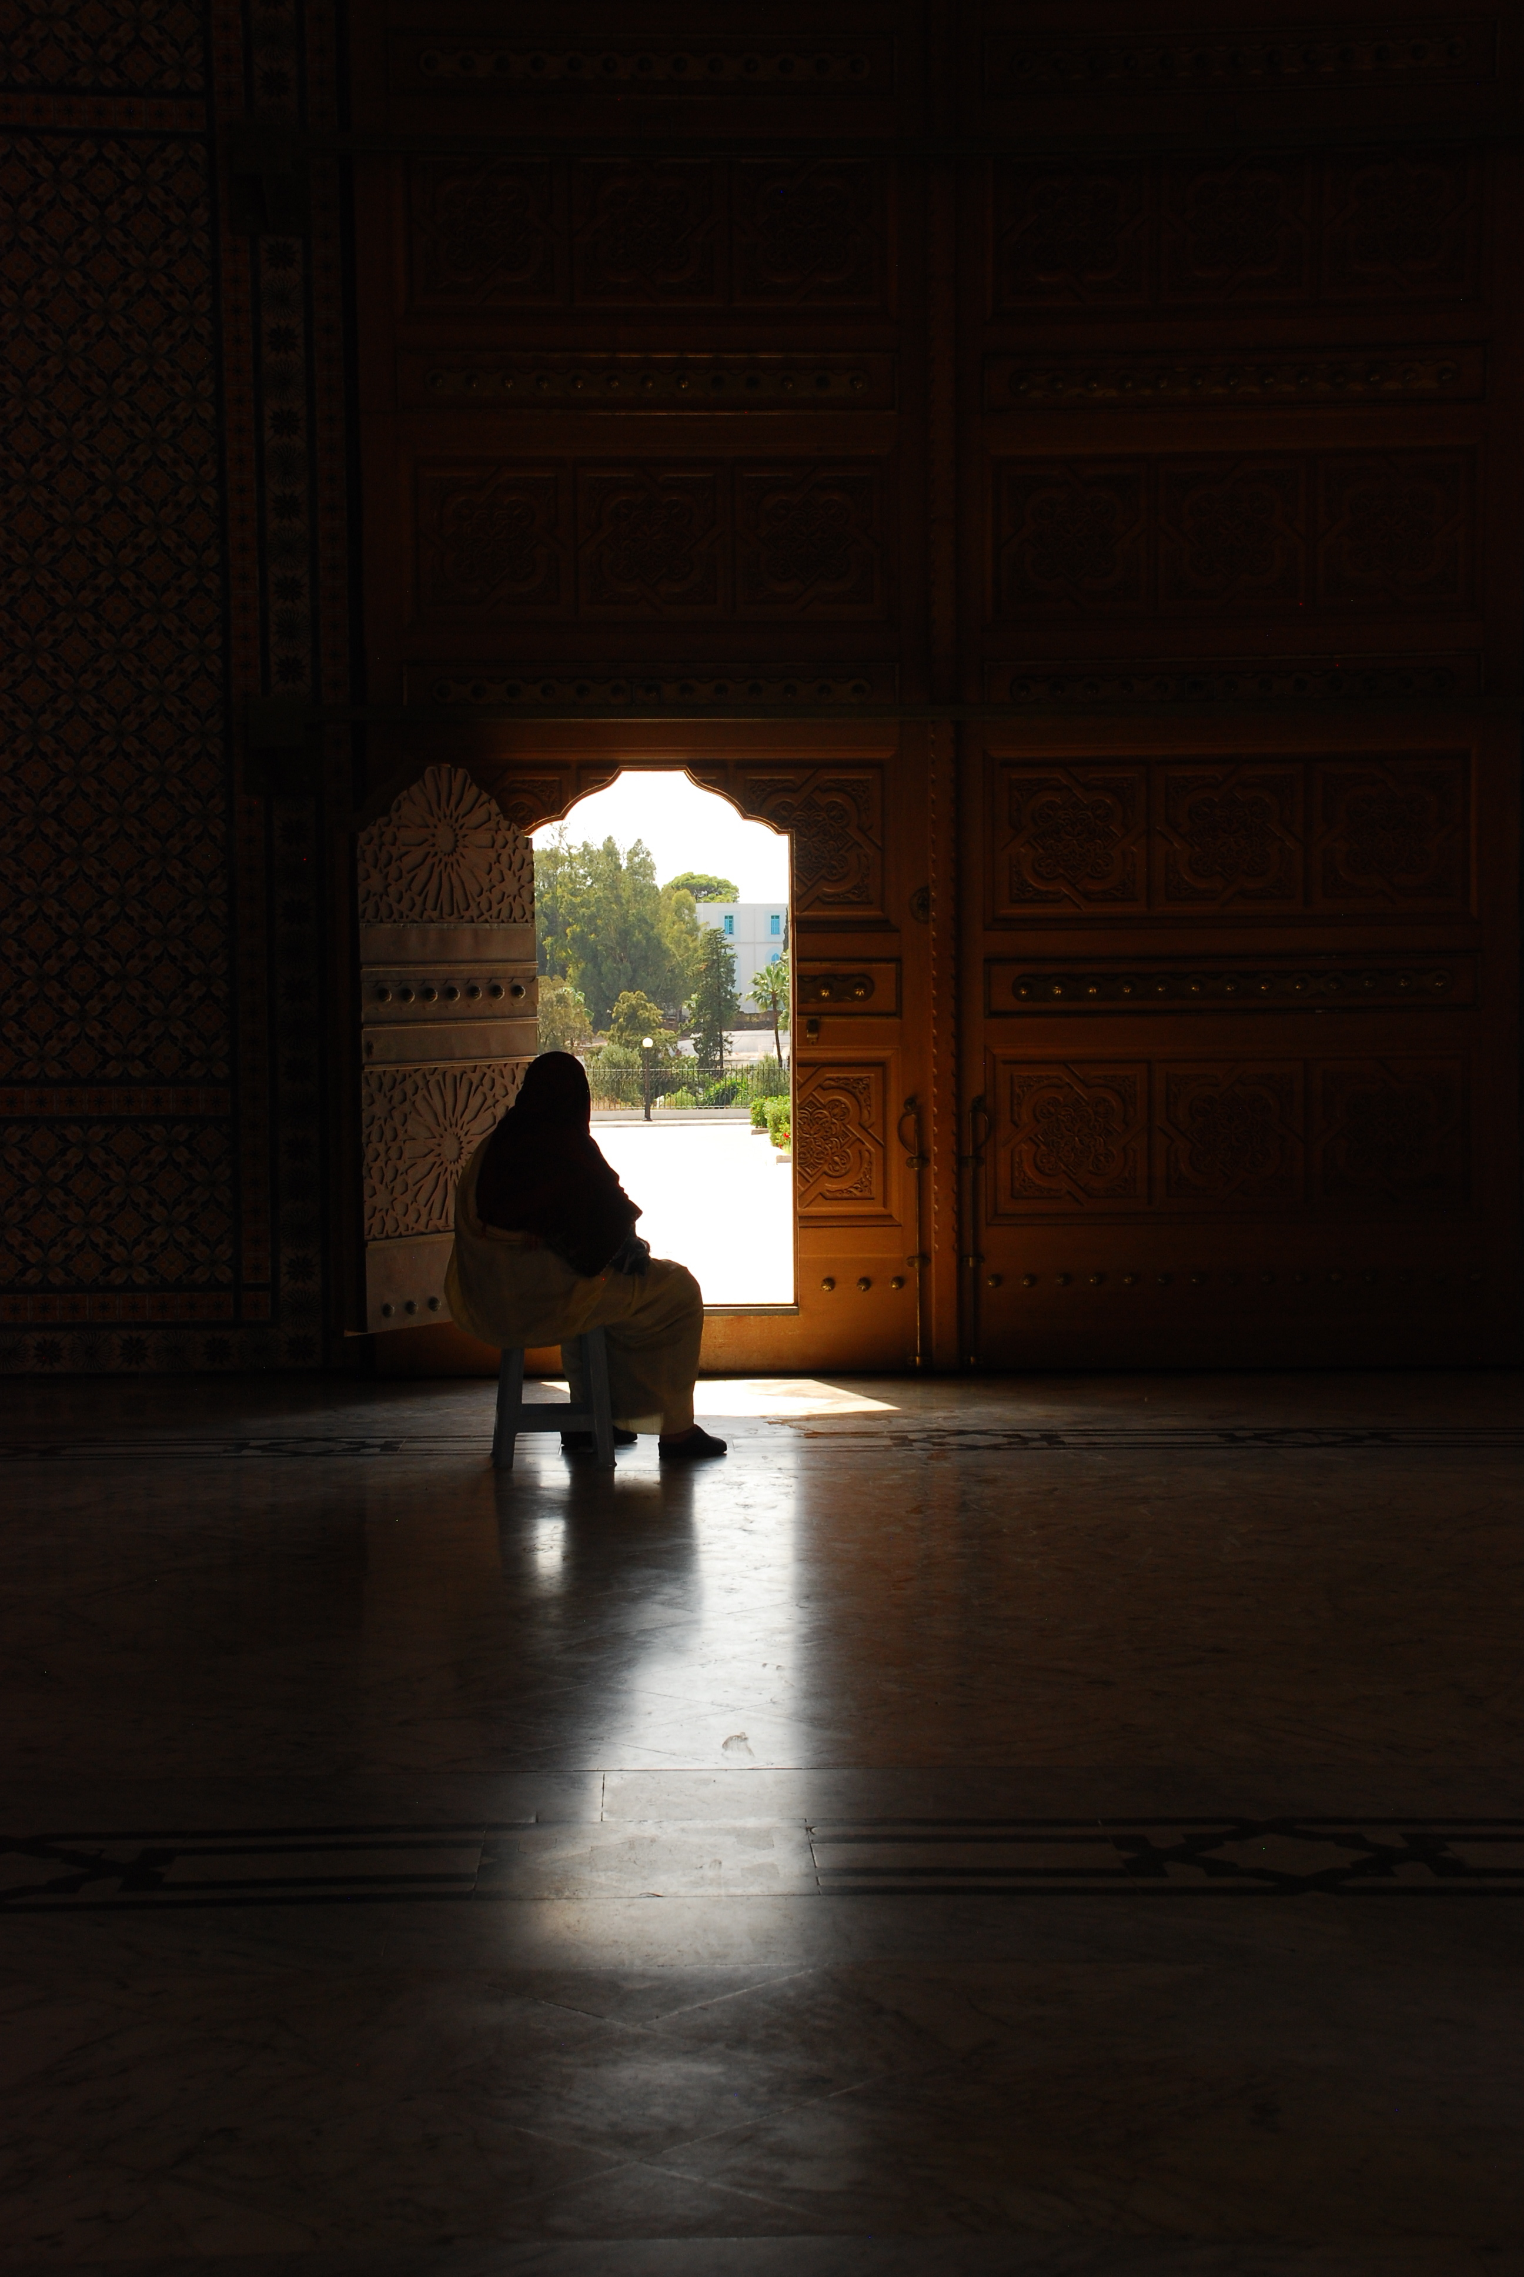
Political Participation of Women in Tunisia Following the Jasmine Revolution
Annalisa Triola
Peter Van Arsdale’s Applied Field Methods Fall 2014
Photo by Annalisa Triola
Table of Contents
Introduction & Purpose 3
Historical and Cultural Context 4
Who, What and Where? 5
Foundations for Research 7
Paradigms 7
Constructs & Indicators 8
Terms 9
Variables 10
Methods 12
Preliminary Data Collection 12
Participant Observation 13
Surveys 14
Semi-Structured Interviews 15
Discussion Groups 16
Possibilities for Further Study 17
Ethics 19
Intended Outcomes 21
Appendix A - Budget 23
Appendix B – Maps 24
Appendix C – Timeline 25
Appendix D – Sample Survey Questions 27
Appendix E – Sample Interview Questions 28

Introduction & Purpose
In the early months of 2011 Tunisians of all walks of life took to the streets following the self-immolation of Mohammed Bouazizi to protest government corruption, unemployment, political repression and other issues. The protests resulted in the ousting of longtime President Zine Al Abidine Ben Ali, the dissolving of the former ruling party, greater democratization, the election of an interim government, and eventually in 2014, a new constitution. An important aspect of the new constitution is the emphasis on gender equality in all aspects of Tunisian life, and the hope for greater integration of women in the governing structures of Tunisia. While women in Tunisia have already enjoyed many more rights than women in the other states in the Middle East and North African Region, the emphasis on women in the new Tunisian constitution shows that there is a wide-spread desire to improve human rights conditions for women in Tunisia.
The purpose of this project is to create a discovery snapshot evaluating the integration of women into the Tunisian political landscape since the 2011 revolution and interim election. The first elections since the revolution and 2011 interim elections are set be held in late October of 2014, allowing us the unusual, and rather fortuitous, opportunity of viewing the outcomes of the constitutional provisions aimed at strengthening the political role of women, in real time. Utilizing election data, interviews, and surveys, this project will examine the political participation of women in the past three elections, both at the national and municipal level, the positions of power women hold in various levels and bodies of the government, and examine the views that certain cohorts of the Tunisian population hold on the political role of women. Since women make up slightly more than half of the adult population of Tunisia the improved integration and participation of women in the Tunisian political systems should be a reliable indicator of the health of Tunisia’s overall democratic transition.

Historical and Cultural Context
Relative to the other nations of the Middle East, North Africa and Maghreb regions, Tunisia has generally fostered a more favorable and progressive climate for gender equality. Women in Tunisia have enjoyed many rights long before their counterparts in the rest of the MENA region and the personal status code is often held up as an example for neighboring countries to follow. Women in Tunisia gained the right to vote in 1957 and gained the right to stand for election in 1959. In 1985 Tunisia signed and ratified the United Nations Convention on the Elimination of all Forms of Discrimination Against Women (CEDAW), far ahead of many of it’s neighbors. Throughout his tenure, former president Habib Bourguiba strove to promote women’s rights and improve the status of women through improving education for girls, and enacting political and social emancipation measures. Further reforms overseen by Ben Ali in the 1990’s established total equality for women in regards in political, civil, social, family, and citizenship rights. However, popular attitudes among the Tunisian population may not necessarily coincide with Tunisian law. This was demonstrated in 2011 following the election of the Islamist Enhada party to head up the interim government following the ousting of Ben Ali, and fears among Tunisia’s women activists that a Islamist ruling party would set back gender equality. While the Enhada has outwardly denounced more repressive Islamic models of government such as Saudi Arabia and the Taliban, the resurgence of the Enhada has prompted a nationwide surge in conservative Islamist and Salafi movements that has worried Tunisian advocates of women’s rights. Additionally the severe distaste for Ben Ali, his regime and his family has also incited resentment in certain cohorts of the population towards the form of top down female emancipation and constant government involvement in women’s civil society prevalent during his time in office. As such some critics of the Ben Ali regme look at the Tunisian feminist movement with the same disgust shown towards the former president.

Who, What and Where?
This project is intended to take place in November of 2014 in Tunisia following the October 23 presidential and parliamentary elections, the first since the interim government was elected in 2011 following the Jasmine Revolution and the ousting of longtime President Zine Al Abidine Ben Ali. This election follows the adaptation of Tunisia’s new constitution, which, among other issues, calls for greater gender equality, improved opportunities for women, and increased integration of women in the political system. This project will not only look at the national elections, but governate elections in Tunisia’s administrative divisions. Because of this the project will primarily take place in Tunis, but will also collect data in the nearby governate of Ariana, and the Southeastern costal governate of Sousse.
Prior to the 2014 elections roughly 27% of the Tunisian legislature was made up of women members, but the there is a drive to increase these numbers with the passing of the new constitution. The elections held on October 23 overall resulted in the defeat of the Islamist Enhada Movement party by Call of Tunisia, a progressive secularist party. While the Call of Tunisia party is seen as progressive and inclusive it is important to note that despite this, none of it’s prominent members or the party’s central leadership are women. While the election data is still being processed, this project asks the questions of how many women will be elected in the 2014 national elections? What steps are being taken by both the government and civil society organizations to improve female participation in politics, if any? Why do Tunisians feel that incorporating women into politics is important? Are the women in government and legislative roles well prepared for their jobs? Are female politicians and candidates as visible as their male counterparts? What challenges are there to incorporating more women into the government? The answers to these thematic questions will create a holistic image of female political integration post 2014-national election.
This project will be conducted in large part by myself, and possibly a number of Tunisian university students interested in the research topic as I will need assistances in area of translation, moderating discussion groups, and possible gatekeepers to various organizations and political parties. The majority of the interactive research (i.e. surveys, discussion groups, participant observation) will revolve around students and Tunisia’s youth population, as the majority of the population is under the age of 35. This project should take about 6 to 8 weeks of in-country fieldwork to complete.

Foundations for Research

Paradigms
All research is guided by at least one paradigm. The primary paradigm for this project is the critical “theory” paradigm as this project is concerned broadly with the democratic transition of the Tunisia people, and movement of women into greater positions of power as the country moves away from the era of repression under Ben Ali, and Habib Bourguiba that came before him. Critical theory is concerned with the emancipation of repressed people and is often concerned with feminist ideals and racial and ethnic issues, so it is relevant to the struggle of Tunisian women attempting to find their voice in their country’s newest chapter. This project makes the assumption that reality is a product of, and subject to, gender-based, political, social, and ethnic forces. Critical theory also places an emphasis on qualitative methods, and as I believe interviews to be the most important source of information on the true state of women in politics, critical theory is appropriate.

Constructs & Indicators
While a paradigm is a philosophy that guides one’s research, a construct is something that shapes your research, and exists theoretically, but is not directly observable or tangible. As such constructs are associated with concepts and indicators that can be observed and measured. The construct this project is concerned with is the opportunity construct, as this projects aims to establish the opportunities that Tunisian women have to participate and shape the political landscape of their country. Indicators of opportunity can include a wide range of phenomena ranging from ratio data such as voter turn out to more difficult to quantify data such as the availability of capacity building workshops to increased visibility of female politicians.

Terms
Throughout this research protocol, a number of terms will be used whose definition and usage may be different in the context of the project than their traditional usages.
- Political Participation – In the context of this project political participation not only refers to the act of voting in official elections but all activities that may be related to ones political life or activities that shape the political landscape. This may include, but is not limited to, voting, running for office, organizing for a political cause, holding political office, working some other position for the government, joining a political party, canvassing for an issue, fundraising or donating money for a cause, candidate or party, writing about a political topic for a publication, studying for a degree in government, and so on.
- Direct Participation – Direct Participation falls under the broad definition of political participation but is limited to only voting in an official election or running for a political office.
- Visibility – Visibility refers to the proliferation of women, women’s issues, female leaders, and feminist civil society in consciousness of the Tunisian citizenry.
- Education and Training – Education and training allude to training or education individuals receive to participate in the government or improve the presence of their movement such someone earning a degree in political science with the intention of pursing a career in the government, or attending a capacity building workshop to train legislators to better represent women’s issues.

Variables
The data to be measured and analyzed will come from a variety of sources, and gleaned through multiple methods, and will result in a number of measured variables. Some of the variables that are intended to be measured are as follows.
Voter Turnout (nationwide) – Voter turn out is a ratio type variable we wish to measure for this project. We want to know both the overall percentage of Tunisians that participated in the elections, the percentage of those that voted who are female, and the overall percentage of the Tunisian female population that participated in the election.
Number of Women holding seats in Parliament – This is also a ratio type variable, where we wish to measure how many of the 217 members of the Tunisian parliament are women following the 2014 elections.
Voter Turnout (surveys) – In addition to measuring the overall voter turnout using the national election data I will be conducting survey’s among Tunisia’s university students. In this survey, students will be asked if they voted in the 2014 national elections. This will be a simple “yes or no” question. The data from this variable can be coded in a nominal manner (0 for no, 1 for yes) and then be used to determine the overall percentage of survey respondents that voted in the 2014 election.
Importance of Women in Government – This variable will also be measured through the student surveys. Students will be asked using a likert scale to rank the importance of women in the government. 1 will signify the lowest ranking of importance, meaning they don’t see any importance in having women in the government, 5 signifying that they believe it is highly important to have women in government positions, and 3 standing in middle signifying that it is important but there are more important issues facing Tunisia than having women in the government.

Methods
When conducting field research, it is imperative to have multiple methods of data collection, as so that the researcher can triangulate the ground truth of the situation. For triangulation one needs at least three methods of data collection, but this project will employ 5 methods of data collection, including both baseline and primary sources, to create the intended holistic picture of female political participation, with the possibility for further study depending on the outcomes of each method. I believe that the planned methods are appropriate for a descriptive and analytic research project.

Preliminary Data Collection
It is important to conduct reconnaissance and baseline data collection in order to establish the context that you will be working in. The preliminary data collection will be focused on secondary sources. For this project we will need to access the election results from the 2014 national elections to establish the national voter turnout, the female voter turnout, and the number of women elected to seats in parliament. Election data can be sourced from a number of organizations including the Center for the Study of Islam and Democracy (based in Tunis), the National Democratic Institute, and the L’instance Supérieure Indépendante pour les Elections (ISIE). This step may also include preparing a literature review of important sources regarding the status of women in Tunisia, the country’s political history, and important moments in the movement.

Participant Observation
Participant observation is key to an ethnographic study. It is used in various stages throughout the project from gaining entrée to identifying key informants. This is also encapsulates my approach to participant observation. Before distributing my surveys and conducting discussion groups I will need to interact with the partner sites and allow the potential future participants to become comfortable speaking with me. This may be just unstructured conversations and interactions with the students in AIESEC or once again acting as an assistant at the American Corner as I have in the past. I also hope to engage in participant observation at various events with my potential collaborator organizations such as conferences, workshops, planning meetings, rallies and so on. Observing and interacting at these events will hopefully lend some insight to the project on the role that women play in political organizing and the scope of women’s empowerment organizations.

Surveys
Since the majority of Tunisia’s population is under the age of 35, and women under the age of 35 outnumber men under 35, it is important to look at the voting habits of this sector of the population and gauge their feelings on women in the government. Sampling for these surveys will be non-probabilistic, and for the sake of ease and convenience surveys will be distributed at the American Corner Tunis, the American Corner Sousse, the University of Manouba and Carthage IHEC chapters of AIESEC international since it will be easy to gain access to the under 35 demographic. While the American Corners are open to any and all looking to improve their English, most of the frequenters of these locations are graduate students at local universities or young professionals looking to improve their language skills. AIESEC is a student run organization so the survey participants will be current or recently graduated university students. These surveys will be group administered and ask demographic, behavioral, attitudinal questions. Participants will be asked their age, gender, education status, if they voted, their feelings on women in the government, an other questions geared towards female political participation. Many of these questions will be asked in a way that is easily coded and quantified such as using likert scales for the attitudinal questions. Versions of the survey will be prepared in English, Arabic and French.

Semi-Structured Interviews
Any student of field research can tell you that interviews are the cornerstone of ethnographic fieldwork and are an essential primary data source. For this project I have chosen semi-structured or semi-formal interviews because I have found it the most beneficial type of interview in past research experiences. The semi-structured interview allows the interviewer to build a rapport with their interviewee and become comfortable with each other. If the interviewer asks the proper type of open ended grand tour questions or sets forth intriguing prompts, the researcher may be able to get all of the information they were looking for by only asking a handful of questions. Semi-formal interviews allow the interviewer to be more open-minded and impose less of their own presumptions on the interview.
For this project I intend to interview a number of different individuals, in including female politicians, organizers and directors at women’s NGOs, and female politics students in order to get their views on female political participation, the challenges women face in political integration, the history of the democratic women’s movements, and other related topics. It is my hope through gaining rapport with these individuals and organizations I will be able use snowballing methods to identify key informants. Potential collaborator organizations for this project include:
- The Center for Islam and Democracy
- Tunisian Association for Democratic Women
- Ministry of Women and Family Affairs
- Tunisian Center for Research, Studies, Documentation, and Information on Women
- Feminist University of Ilhem Marzouki

Discussion Groups

Focus and discussion groups are a cost effective way of gaining unique insights and gaining a large amount of information in one event. I have chosen a discussion group over a focus group however due to focus groups needing to be homogenous, while discussion groups tend to involve a more diverse group of participants. I hope to host a discussion group session at the American Corner Library in Tunis as I know that they host group discussions in English on a weekly basis. The advanced discussion group is around 8 to 12 students and each week the discussion revolves around a topic that is discussed in depth, the topics can range from European politics to UFOs, so I believe that these student will be more than capable of discussing the role of women in politics at length. Group discussions at American Corner are always monitored by the library coordinator and another assistant (myself in this case), so this will be ideal for conducting an effective discussion group.

Possibilities for Further Study
Through methods such as participant observation, surveys, discussion groups, and semi-structured interviews, I may come contact with individuals that possess information, experiences, or contacts that may prove useful to the goals of the project. These people may become gatekeepers or key informants. If some of the life events of these individuals lend themselves to establishing the ground truth for this project, it may even been appropriate to create an event calendar.
Gaining Entrée
Getting the lay of the land and gaining entrée into your preferred cohort of study can be challenging for any researcher without the proper preparation, experience, and contacts. In the case of Tunisia, I have previously lived in Tunis during fall of 2013, and had the opportunity to reside in and visit all of the intended locations of study, so I already posses some familiarity of the location. During my time in Tunis I volunteered at the Tunis American Corner library, hosted by AmidEast, and the Tunis-Manouba Primary School for the Disabled, while working with the Medina and Carthage chapters of AIESEC international, so I am not only familiar with the research locations but I have networks of connections to access for my research. All of these groups can be utilized for social mapping to gain insights into to who, where, and what to focus my efforts on.
Of particular importance are the American Corner libraries. I have close personal ties to the individuals who manage the American Corner’s in both Tunis and Sousse, so these locations may be used a possible base of operations for some part of the research activities. Additionally, the primary patrons of the American Corners are university students, which are the primary desired demographic for my surveys on the voting habits of Tunisia’s youth. Since many of the students who frequent the American corners are proficient in English this may also be a promising location to scout a potential translator for the project. My hope is that through the American Corner I can find one or two individuals that can assist me with the social mapping necessary for this project including locating important organizations, meeting places, and safe places to conduct interviews.
Many of the patrons of the American corner are also members of various political groups or local community organizations around Tunisia and could also potentially act as gatekeepers to NGOs, political parties, and community organizers that would prove useful for the project. Even with possible connections from the American Corner the most challenging part of this project will be gaining entry into and gaining the cooperation of the organizations and individuals I most want to interview. During a previous field research project conducted in 2012 in Rabat, Morocco, I found it very difficult to establish communication between myself and organizations I was trying to get in touch with using methods that would be considered orthodox and appropriate here in the US, such as email or telephone calls. Instead, on a tip from an assistant at the institute I was studying at, I decided to seek out the physical locations of the organizations in question in hopes someone would speak with me or point me in the direction of someone who would. This approach was highly successful and led to either archival access or key informant interviews at three of the four organizations I wished to contact.

Ethics
The privacy, safety and confidentiality of those you involve in your research are highly important to the outcomes of your project. Data obtained in an unethical way or without informed consent or the comfort of the participants taken into consideration is not data one should seek to use for their research. When conducting my research it is extremely important to remember the four ethical principles for good research; truth, justice, benevolence and non-malevolence. Seek to preserve the voice of participants while respecting their autonomy and dignity. Further more always strive to do good, and at the very least do no harm. With these principles guiding my research I have formulated an approach to guide my research ethics.
First it is incredibly important to obtain informed consent from all participants. Many people may be hesitant to participate in study or discussion group if they do not know what the purpose or intended outcomes the research project. This is why it will be important to discuss the project and it’s content and intent thoroughly with interviewees, discussion groupsvolunteers, and survey participants before informed consent is obtained. I will prepare written statements in Arabic and French if the need arises as well in order to better inform potential participants. IRB forms will then be used to gain the informed consent of participants. I hope to have an open dialogue with all those that come in contact with the project so that they may ask me about any aspect of the project at any time.
Next one must respect the safety, dignity and comfort of the participants. During a previous trip to Tunisia in Fall of 2013 I found that many people were reluctant to discuss issues related to the revolution, the current ruling party, the election and constitution in many public and even semi private places, citing their safety as a concern. A key concern with this project will be to find locations that participants feel comfortable to discuss the issues at hand. One must treat the safety concerns of the participant as valid and real. As such participants will be informed that they may cease their participation at any point in the project if they feel uncomfortable. A key concern with this project will be to find locations that participants feel comfortable to discuss the issues at hand. This may involve reserving private spaces at the American Corner Libraries, utilizing the private homes of trusted colleagues or hotel rooms.
Lastly privacy and confidentiality of the participants are of the upmost concern. In addition to finding safe places to interact with participants, we must respect their privacy and the confidentiality of any data provided to the research team. For the surveys, participants involved will remain totally anonymous, as participants will only be asked their gender and age, and no other indentifying traits. In the case of interviews, from my field research experience in Morocco, some participants were highly enthusiastic about lending their name to the project, while others were less than keen on being associated with the project. Once again this highlights the importance of thoroughly informing participants on the intentions of the project. I will pay special attention to the way interviewees wish to indentified as some may insist on me using their real names, while some may wish to use a different name, and other may want to remain totally anonymous. Participants in the discussion groups will be given pseudonyms, and they will not be identified as patrons of the American Corner.

Intended Outcomes
The purpose of this project is to create a holistic image of the political participation of Tunisian women following the revolution and the enacting of the new constitution. Through the use of election data, voting habit surveys, participant observation, interviews and discussion groups, we should be able to confidently create that image. It is my hope that the data collected through this project and report assembled from it, Middle East scholars and Tunisian activists will be able to assess the current political integration of women, the progress that has been made and what steps may need to be made in the future. Furthermore I hope that through the connections I make during this project, those I interact with are reminded of the important role their country plays in leading progressive reform in the Middle East and North Africa Region.

Appendix A - Budget

Airfare from Denver to Tunis (roundtrip) - $1100
Lodging - $700 for apartment rental & hostels
Transportation - $400 for taxis, louage, car rental
Food - $500
Survey/Discussion group materials - $50

Appendix B – Maps
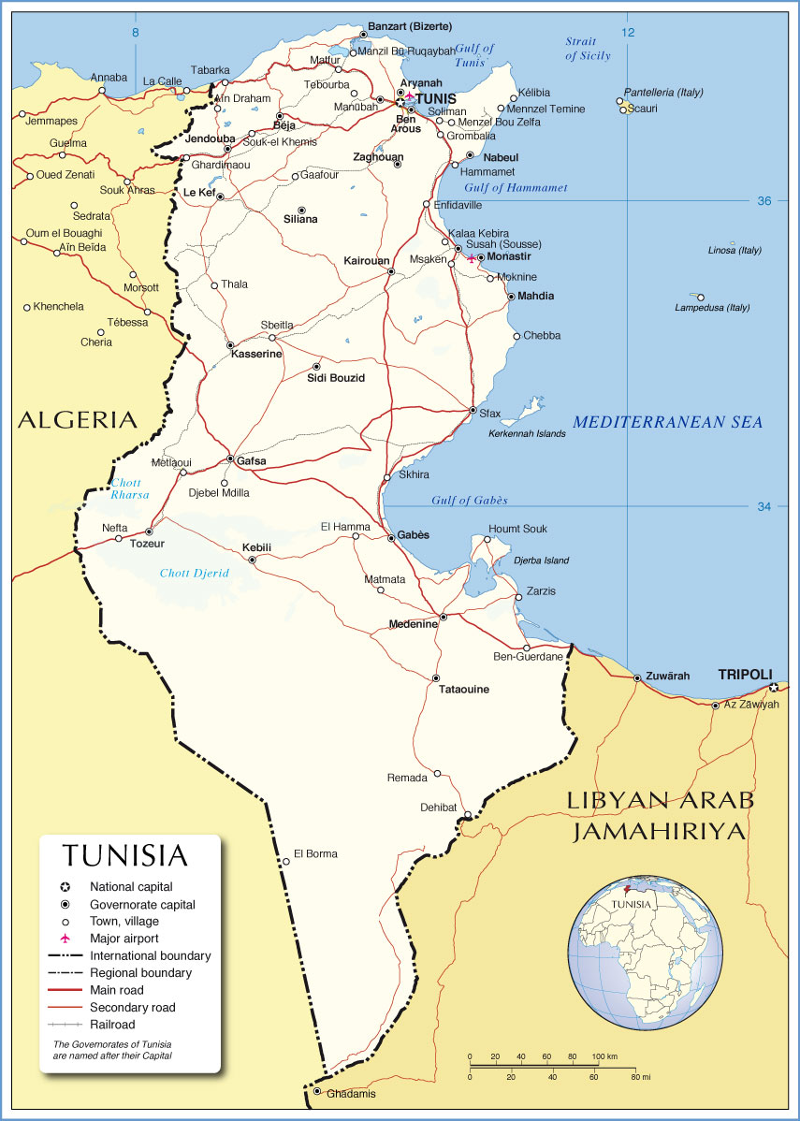

Appendix C – Timeline

- Week 1
  - Get established at American Corner Tunis
    - Search for translators
  - Visit potential collaborator organizations
    - Set up interviews if possible
    - make calendar of upcoming events
  - Analyze election data
  - Meet with AISEC Medina and Carthage
- Week 2
  - Distribute surveys at American Corner Tunis
    - Code and quantify results
  - Indentify potential research assistants
  - Visit potential collaborator organizations
    - Set up interviews if possible
  - Begin conducting interviews
- Week 3
  - Continue to conduct interviews
  - Conduct discussion group at American Corner Tunis
  - Distribute Surveys at AIESEC Medina and Carthage
    - Code and quantify results
  - Make arrangements with Sousse contacts
- Week 4
  - Organize discussion group findings
  - Organize survey findings so far
  - Conduct interviews if need be
- Week 5
  - Travel to Sousse
  - Visit American Corner Sousse
  - Distribute Surveys at American Corner Sousse
    - Code and quantify results
  - Conduct Discussion group at American Corner Sousse
  - Conduct interviews with Sousse collaborators
- Week 6
  - Return to Tunis
  - Organize findings form Sousse surveys and discussion groups
  - Set up key informant interviews if any
- Week 7
  - Analyze and organize complete results
  - Conduct follow up interviews if need be
- Week 8
  - Analyze and organize complete results
  - Prepare for departure form Tunis

Appendix D – Sample Survey Questions
- How old are you?
- Are you male or female?
- Are you a student? (circle one) Yes No
- What do you study
- Did you vote in the 2014 National Parliamentary elections? (circle one)
Yes No
- Did you vote the 2014 National Presidential Elections? (circle one)
Yes No
- Can you name any female parliamentary or presidential candidates?
- Do you wish there were more women in the government? (circle one)
Yes No
- Do you think that the women in parliament are well prepared for their jobs? (circle one) Yes No
- On a scale of 1 to 5, 1 being disagree strongly, 5 being agrees strongly, how much do you agree with this statement:
“It is important for Tunisia’s future to have many women in government”
- On a scale of 1 to 5, 1 being the least important, 5 being the most important, how important do you think it is to have women in the government?
- Do you think that women’s issues are well represented in the Tunisian government? (circle one) Yes No
- What is the most important issue for Tunisia’s women today?

Appendix E – Sample Interview Questions

Can you tell me about the history and purpose of your organization?
What is your role at this organization?
What made you want to be part of this organization?
What is your organization doing to improve the political role of women?
What are the biggest challenges facing Tunisia’s women?
Do you think that the women of Tunisia better off now than they were before the revolution?

Central Intelligence Agency. "Tunisia: World Fact Book." The Work Factbook. https://www.cia.gov/library/publications/the-world-factbook/geos/ts.html (accessed October 25, 2014).
"Status Of Women." Tunisia Country Review (2013): 168-170. Business Source Complete. Web. 30 Oct. 2014
"Political Conditions." Tunisia Country Review (2010): 9-18. Business Source Complete. Web. 30 Oct. 2014.
Gray, Doris H. "Tunisia After The Uprising: Islamist And Secular Quests For Women's Rights." Mediterranean Politics 17.3 (2012): 285-302. Academic Search Complete. Web. 1 Nov. 2014.
"Proportion of seats held by women in national parliaments (%)." The World Bank. N.p., 10 May 2014. Web. 22 Oct. 2014. <http://data.worldbank.org/indicator/SG.GEN.PARL.ZS>.
Central Intelligence Agency. "Tunisia: World Fact Book." The Work Factbook. https://www.cia.gov/library/publications/the-world-factbook/geos/ts.html (accessed October 25, 2014).
It is also important to note that women under the age of 35 outnumber men under the age of 35 in Tunisia.
Van Ardsdale, Peter. "Emergent Paradigms and the Science of Culture." Applied Field Methods Lecture. University of Denver, Denver. 24 Sept. 2014. Class Lecture.
As found in “The Five C’s” handout distributed during lecture. Van Ardsdale, Peter. "Emergent Paradigms and the Science of Culture." Applied Field Methods Lecture. University of Denver, Denver. 24 Sept. 2014. Class Lecture.
Pelto, Pertti J.. "Analysis of Qualitative Text Data: Basic Steps." Applied ethnography: guidelines for field research. Walnut Creek: Left Coast Press, 2013. 199-215. Print.
"Appendix: Levels of Measurement." Applied Field Methods: A Manual of Practice. Ed. Peter Van Ardsdale. 3rd ed. Centennial: Center for Cultural Dynamics, 2005. 191-193. Print.
Van Ardsdale, Peter. "Preface: Ground Truth, Ethics, and Field Methodologies." Applied Field Methods: A Manual of Practice. 3rd ed. Centennial: Center for Cultural Dynamics, 2005. 5-9. Print.
Beebe, James. "Data Collection - Multiple Data Sources and Triangulation." Rapid Qualitative Inquiry. 2nd ed. London: Rowman & Littlefield, 2014. 53-77. Print.
Van Ardsdale, Peter. "Variables; Basic Data Collection, Coding, and Analysis." Applied Field Methods Lecture. University of Denver, Denver. 1 Oct 2014. Class Lecture.
Pelto, Pertti J.. "Steps of Applied Ethnographic Field Research." Applied ethnography: guidelines for field research. Walnut Creek: Left Coast Press, 2013. 43-57. Print.
This is another instance where I wish to employ snowballing, where I hope to indentify key informants at these events, or conversely gain invitation to these event though my interviews.
Pelto, Pertti J.. "Participant Observation." Applied ethnography: guidelines for field research. Walnut Creek: Left Coast Press, 2013. 127-140. Print.
Follenweider, Tobin, Jill Henry, and Monica Orga. "Transforming Research Opportunities through Participant Observation." Applied Field Methods: A Manual of Practice. Ed. Peter Van Arsdale. 3rd ed. Centennial: Center for Cultural Dynamics, 2005. 52-63. Print.
Chang, Linda. "Concepts and Techniques in Sampling." Applied Field Methods: A Manual of Practice. Ed. Peter Van Arsdale. 2nd ed. Centennial: Center for Cultural Dynamics, 2005. 75-79. Print.
Ervin, Alexander M. "Quantification through Social Indicators and Questionnaires." Applied Anthropology: Tools and Perspectives for Contemporary Practice. 2nd ed. Boston: Pearson, 2005. 189-206. Print.
See Appendix for sample survey questions.
I am concerned that this way of finding survey participants may be somewhat biased as most respondents will be attending university or attaining advanced degrees. I will have to use a snowball approach to seek out a more varied sample of youth participants.
Sanders, D. Todd. "The Interview: The Cornerstone of Field Work." Applied Field Methods: A Manual of Practice. Ed. Peter Van Arsdale. 2nd ed. Centennial: Center for Cultural Dynamics, 2005. 28-33. Print.
Ervin, Alexander M. "Participant Observation and Key Informant Interviewing." Applied Anthropology: Tools and Perspectives for Contemporary Practice. 2nd ed. Boston: Pearson, 2005. 160-174. Print.
Beebe, James. "Data Collection - Multiple Data Sources and Triangulation." Rapid Qualitative Inquiry. 2nd ed. London: Rowman & Littlefield, 2014. 53-77. Print.
See Appendix for sample interview questions
Pelto, Pertti J.. "Key Informants and Group Discussions." Applied ethnography: guidelines for field research. Walnut Creek: Left Coast Press, 2013. 87-102. Print.
Van Ardsdale, Peter. "Focus Groups; Social Mapping/Network Analysis; Event Calendars; Content Analysis." Applied Field Methods Lecture. University of Denver, Denver. 29 Oct. 2014. Class Lecture.
Ervin, Alexander M. "Focus Groups and Other Group-Interviewing Techniques." Applied Anthropology: Tools and Perspectives for Contemporary Practice. 2nd ed. Boston: Pearson, 2005. 175-188. Print.
Van Ardsdale, Peter. "Focus Groups; Social Mapping/Network Analysis; Event Calendars; Content Analysis." Applied Field Methods Lecture. University of Denver, Denver. 29 Oct. 2014. Class Lecture.
Pelto, Pertti J.. "Gaining Entry to a Study Site." Applied ethnography: guidelines for field research. Walnut Creek: Left Coast Press, 2013. 59-72. Print.
Pelto, Pertti J.. "Social Mapping and Sketch Mapping." Applied ethnography: guidelines for field research. Walnut Creek: Left Coast Press, 2013. 73-85. Print.
Van Ardsdale, Peter. "Preface: Ground Truth, Ethics, and Field Methodologies." Applied Field Methods: A Manual of Practice. 3rd ed. Centennial: Center for Cultural Dynamics, 2005. 5-9. Print.
Ervin, Alexander M. "Ethics in Applied Research and Practice." Applied Anthropology: Tools and Perspectives for Contemporary Practice. 2nd ed. Boston: Pearson, 2005. 160-174. Print.
Ervin, Alexander M. "Ethics in Applied Research and Practice." Applied Anthropology: Tools and Perspectives for Contemporary Practice. 2nd ed. Boston: Pearson, 2005. 160-174. Print.
Airfare estimates are student fares from STA Travel for one person
This includes purchases to feed research assistants and meals to be cooked for anyone who graciously hosts us in their home.
Includes the costs of printing and the cost of providing coffee and refreshments for the discussion groups.

